

**BCS2213 Formal Methods**

**THE CANNIBALS**

|  |  |
| --- | --- |
| MAHDI HISHAMUDDIN BIN ABDUL AZIZ | CB13009 |
| NUR SYUHAIDAH BINTI ISMAIL | CB13006 |
| NORFATINFAIZAH BIN ABD.RAHIM | CB13011 |
| KHAIRUNNISAK NOORDIN | CB12018 |
| NORSYAFIQAH BINTI JAMALUDDIN | CB12017 |
| MOHD LUQMAN NURHAKIM BIN AZMI | CB12014 |
| NUR ELYANIE NAZIRAH BINTI MAZLAN | CB13013 |

Lecturer: [PROF DR. VITALIY MEZHUYEV](http://fskpnp.ump.edu.my/moodle/user/view.php?id=10276&course=1)

**TABLE CONTENT**

|  |  |
| --- | --- |
| CONTENT | M/S |
| **Acknowledgement** | 3 |
| **Background** | 4 |
| **Introduction** | 5 |
| **TLA Model** | 6 |
| **UPPAAL Model** | 12 |
| **Conclusion** | 16 |
| **Reference** | 17 |

**ACKNOWLEDGEMENT**

We are very appreciate and grateful because we have a very patient and helpful lecturer, our formal method [Prof Dr. Vitaliy Mezhuyev](http://fskpnp.ump.edu.my/moodle/user/view.php?id=10276&course=1), for his invaluable guidance, empowering support and profound advice throughout the preparation and realization of this group assignment.

Deepest thanks for his invaluable guidance and advice, continuous encouragement and stimulating suggestions helped us in all the time while developing this report and system.

From this assignment, it is very good experience for us how to write a apply principals of formal methods in writing a software functional throughout the development of the project.

We implemented the practical theoretical which we had learned at class. Finally, this project has been done completely and we believe that the outcome of this project is bringing a lot of benefits to us and understand the formal specification TLA and specification UPPAAL while applying the principal in software development project, and definitely cooperation from each of the team member to completed this project on time.

Finally, thanks to Almighty God for giving us good health, strength and perseverance to complete this project

**BACKGROUND**

Cannibalism (from Caníbales, the Spanish name for the Caribs,[1] a West Indies tribe that formerly practiced cannibalism)[2] is the act or practice of humans eating the flesh or internal organs of other human beings. It is also called anthropophagy. A person who practices cannibalism is called a cannibal. The expression "cannibalism" has been extended into zoology to mean one individual of a species consuming all or part of another individual of the same species as food, including sexual cannibalism.

The Island Carib people of the Lesser Antilles, from whom the word cannibalism derives, acquired a long-standing reputation as cannibals following the recording of their legends in the 17th century.[3] Some controversy exists over the accuracy of these legends and the prevalence of actual cannibalism in the culture. Cannibalism was widespread in the past among humans in many parts of the world, continuing into the 19th century in some isolated South Pacific cultures, and to the present day in parts of tropical Africa. Cannibalism was practiced in New Guinea and in parts of the Soloman islands, and flesh markets existed in some parts of Melenesia.[4] Fiji was once known as the 'Cannibal Isles'.[5] Cannibalism has been well documented around the world, from Fiji to the Amazon Basin to the Congo to Māori New Zealand.[6] Neanderthals are believed to have practiced cannibalism,[7][8] and Neanderthals may have been eaten by anatomically modern humans.[9]

**INTRODUCTION**

The formal method title project that has been choosing for our group is about cannibals. There are two tools that have been use for this project. The first is Temporal Logic of Actions and second is UPAAL. Temporal logic of actions (TLA) is a logic developed by Leslie Lamport, which combines temporal logic with a logic of actions. It is used to describe behaviours of concurrent systems. UPPAAL is an integrated tool environment for modeling, validation and verification of real-time systems modeled as networks of timed, extended with data types (bounded integers, arrays etc.). The cannibals problem is Three cannibals and three anthropologists have to cross a river. The boat they have is only big enough for two people. The cannibals will do as requested, even if they are on the other side of the river, with one exception. If at any point in time there are more cannibals on one side of the river than anthropologists, the cannibals will eat them. What plan can the anthropologists use for crossing the river so they don't get eaten?

The solution that have discussed is:

1. Bring anthropologists and cannibal across in boat.
2. Drop cannibal off.
3. Go back and put the other two cannibals in boat.
4. Drop one off and go across.
5. Now put two anthropologists in boat and send them across.
6. Drop one off and pick up a cannibal.
7. Drop off the cannibal and pick up the anthropologists.
8. Bring them across and drop them both off and have the cannibal go pick up the other two in two trips.
9. Drop them all off

**TLA MODEL**

------------------------------ MODULE cannibal ------------------------------

(* The anthropologists and Cannibals Problem solved using TLA+ *)

(* Everybody starts on the lhs of the river *)

(* The goal is to get everybody safely across the river *)

(* The boat can only carry 1 or 2 (never none) *)

(* If the cannibals ever outnumber the anthropologists, they will eat them!*)

(* NOTE-there CAN legally be more cannibals than anthropologists on the same *)

(* side of the river when the number of anthropologists = 0 *)

(* *)

(***************************************************************************)

EXTENDS Naturals

VARIABLES cl, \* The number of cannibals on the lhs of the river.

ml, \* The number of missionaries on the lhs of the river.

cr, \* The number of cannibals on the rhs of the river.

mr, \* The number of missionaries on the rhs of the river.

boat \* 0 when boat is on the lhs, 1 when the boat is on the rhs

TypeOK == /\ cl \in 0..3

/\ ml \in 0..3

/\ cr \in 0..3

/\ mr \in 0..3

/\ boat \in 0..1

Init == /\ cl = 3

/\ ml = 3

/\ cr = 0

/\ mr = 0

/\ boat = 0

(***************************************************************************)

(* Now we define the actions that can happen. There are ten. *)

(* Because the boat changes sides each time a crossing is made, only 5 are *)

(* possible at any given time. *)

(***************************************************************************)

BoatLR1C == /\ boat = 0

/\ cl >= 1

/\ \/ mr = 0

\/ mr >= cr+1

/\ boat' = 1

/\ cl' = cl-1

/\ UNCHANGED <<ml>>

/\ cr' = cr+1

/\ UNCHANGED <<mr>>

BoatLR2C == /\ boat = 0

/\ cl >= 2

/\ \/ mr = 0

\/ mr >= cr+2

/\ boat' = 1

/\ cl' = cl-2

/\ UNCHANGED <<ml>>

/\ cr' = cr+2

/\ UNCHANGED <<mr>>

BoatLR1M == /\ boat = 0

/\ ml >= 1

/\ \/ ml-1 = 0

\/ ml-1 >= cl

/\ mr+1 >= cr

/\ boat' = 1

/\ ml' = ml-1

/\ UNCHANGED <<cl>>

/\ mr' = mr+1

/\ UNCHANGED <<cr>>

BoatLR2M == /\ boat = 0

/\ ml >= 2

/\ \/ ml-2 = 0

\/ ml-2 >= cl

/\ mr+2 >= cr

/\ boat' = 1

/\ ml' = ml-2

/\ UNCHANGED <<cl>>

/\ mr' = mr+2

/\ UNCHANGED <<cr>>

BoatLR1C1M == /\ boat = 0

/\ cl >= 1

/\ ml >= 1

/\ \/ ml-1 = 0

\/ ml-1 >= cl-1

/\ mr+1 >= cr+1

/\ boat' = 1

/\ cl' = cl-1

/\ ml' = ml-1

/\ cr' = cr+1

/\ mr' = mr+1

BoatRL1C == /\ boat = 1

/\ cr >= 1

/\ \/ ml = 0

\/ ml >= cl+1

/\ boat' = 0

/\ cr' = cr-1

/\ UNCHANGED <<mr>>

/\ cl' = cl+1

/\ UNCHANGED <<ml>>

BoatRL2C == /\ boat = 1

/\ cr >= 2

/\ \/ ml = 0

\/ ml >= cl+2

/\ boat' = 0

/\ cr' = cr-2

/\ UNCHANGED <<mr>>

/\ cl' = cl+2

/\ UNCHANGED <<ml>>

BoatRL1M == /\ boat = 1

/\ mr >= 1

/\ \/ mr-1 = 0

\/ mr-1 >= cr

/\ ml+1 >= cl

/\ boat' = 0

/\ mr' = mr-1

/\ UNCHANGED <<cr>>

/\ ml' = ml+1

/\ UNCHANGED <<cl>>

BoatRL2M == /\ boat = 1

/\ mr >= 2

/\ \/ mr-2 = 0

\/ mr-2 >= cr

/\ ml+2 >= cl

/\ boat' = 0

/\ mr' = mr-2

/\ UNCHANGED <<cr>>

/\ ml' = ml+2

/\ UNCHANGED <<cl>>

BoatRL1C1M == /\ boat = 1

/\ cr >= 1

/\ mr >= 1

/\ \/ mr-1 = 0

\/ mr-1 >= cr-1

/\ ml+1 >= cl+1

/\ boat' = 0

/\ cr' = cr-1

/\ mr' = mr-1

/\ cl' = cl+1

/\ ml' = ml+1

Next == \/ BoatLR1C

\/ BoatLR2C

\/ BoatLR1M

\/ BoatLR2M

\/ BoatLR1C1M

\/ BoatRL1C

\/ BoatRL2C

\/ BoatRL1M

\/ BoatRL2M

\/ BoatRL1C1M

Spec == Init /\ [][Next]_<<cl, ml, cr, mr, boat>>

-----------------------------------------------------------------------------

Solved == /\ cl = 0

/\ ml = 0

/\ cr = 3

/\ mr = 3

/\ boat = 1

NotSolved == ~Solved

(*NotSolved == \/ cl # 0

\/ ml # 0

\/ cr # 3

\/ mr # 3

\/ boat # 1*)

=============================================================================

**The variable description**

|  |  |
| --- | --- |
| **Variable** | **Description** |
| **cl** | The number of cannibals on the left hand side of the river. |
| **ml** | The number of anthropologists on the left hand side of the river. |
| **cr** | The number of cannibals on the right hand side of the river. |
| **mr** | The number of anthropologists on the right hand side of the river. |
| **boat** | 0 when boat is on the lhs, 1 when the boat is on the right hand side |

**TLA XML FILE**

<?xml version="1.0" encoding="utf-8"?><!DOCTYPE nta PUBLIC '-//Uppaal Team//DTD Flat System 1.1//EN' 'http://www.it.uu.se/research/group/darts/uppaal/flat-1_1.dtd'><nta><declaration>// Place global declarations here.

int cl=3;

int ml=3;

int cr=0;

int mr=0;

</declaration><template><name x="5" y="5">Template</name><declaration>// Place local declarations here.

</declaration><location id="id0" x="-496" y="-32"><name x="-512" y="-16">END</name></location><location id="id1" x="-496" y="-152"><name x="-560" y="-184">BoatRL3c3m</name></location><location id="id2" x="-392" y="-152"><name x="-448" y="-184">BoatRL1c1m</name></location><location id="id3" x="-312" y="-152"><name x="-344" y="-184">BoatRL2m</name></location><location id="id4" x="-200" y="-152"><name x="-232" y="-184">BoatRL1m</name></location><location id="id5" x="-104" y="-152"><name x="-128" y="-184">BoatRL2c</name></location><location id="id6" x="-16" y="-152"><name x="0" y="-160">BoatRL1c</name></location><location id="id7" x="-16" y="-288"><name x="-24" y="-320">BoatLR1c1m</name></location><location id="id8" x="-104" y="-288"><name x="-112" y="-320">BoatLR2m</name></location><location id="id9" x="-192" y="-288"><name x="-208" y="-320">BoatLR1m</name></location><location id="id10" x="-280" y="-288"><name x="-296" y="-320">BoatLR2c</name></location><location id="id11" x="-392" y="-288"><name x="-392" y="-320">BoatLR1c</name></location><location id="id12" x="-504" y="-288"><name x="-514" y="-318">Initial</name></location><init ref="id12"/><transition><source ref="id1"/><target ref="id0"/></transition><transition><source ref="id2"/><target ref="id1"/><label kind="assignment" x="-472" y="-144">cl=cl-1,ml=ml-1,

cr=cr+1,

mr=mr+1</label></transition><transition><source ref="id3"/><target ref="id2"/><label kind="assignment" x="-376" y="-144">cl=cl-1,

ml=ml-1,

cr=cr+1,

mr=mr+1</label></transition><transition><source ref="id4"/><target ref="id3"/><label kind="assignment" x="-280" y="-144">cl=cl+1,

ml=ml+1,

cr=cr-1,

mr=mr-1</label></transition><transition><source ref="id5"/><target ref="id4"/><label kind="assignment" x="-176" y="-144">cl=cl-1,

ml=ml-2,

cr=cr+1,

mr=mr+2</label></transition><transition><source ref="id6"/><target ref="id5"/><label kind="assignment" x="-80" y="-144">cl=cl+1,

cr=2-1</label><nail x="-88" y="-152"/></transition><transition><source ref="id7"/><target ref="id6"/><label kind="assignment" x="0" y="-256">cl=2-1,

ml=ml+1,

cr=cr+1,

mr=mr-1</label></transition><transition><source ref="id8"/><target ref="id7"/><label kind="assignment" x="-88" y="-288">cl=cl+1,

ml=ml+1,

cr=cr-1,

mr=mr-1</label></transition><transition><source ref="id9"/><target ref="id8"/><label kind="assignment" x="-176" y="-288">cl=cl-1,

ml=ml-1,

cr=cr+1,

mr=mr+1</label></transition><transition><source ref="id10"/><target ref="id9"/><label kind="assignment" x="-264" y="-280">cl=cl+1,

ml=ml-1,

cr=cr-1,

mr=mr+1</label></transition><transition><source ref="id11"/><target ref="id10"/><label kind="assignment" x="-360" y="-288">cr=cr+1,

cl=cl-1</label></transition><transition><source ref="id12"/><target ref="id11"/><label kind="assignment" x="-472" y="-288">cr=cr+1,

cl=cl-1</label></transition></template><system>// Place template instantiations here.

Process = Template();

// List one or more processes to be composed into a system.

system Process;</system></nta>

**UPPAAL**

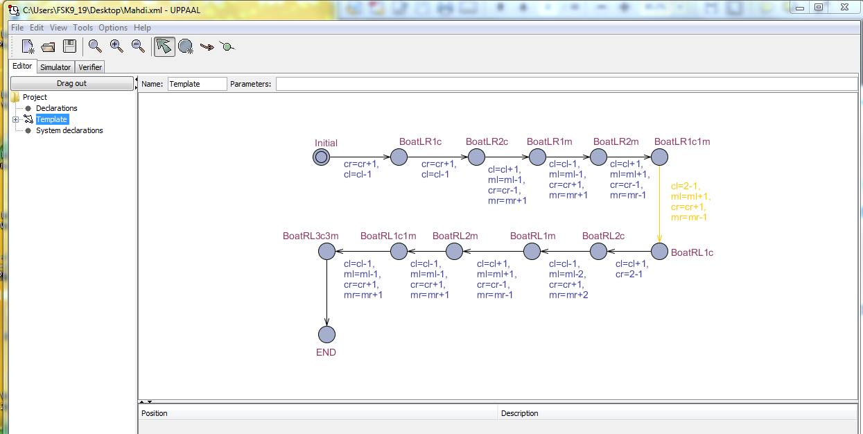

**Figure 1 : UPPAAL**

**Process Description**

|  |  |
| --- | --- |
| Statement | Variable |
| Initial | cl = 3  ml = 3  cr = 0  mr =0 |
| Boat LR1C | cl = 3  ml = 3  **cr = 1**  mr =0 |
| Boat LRC2 | cl = 1  ml = 3  **cr = 2**  mr =0 |
| Boat LR1M | cl = 2  ml = 2  cr = 1  mr =1 |
| Boat LR2M | cl = 1  ml = 1  cr = 2  mr =2 |
| Boat LR1CM1 | cl = 2  ml = 2  cr = 1  mr =1 |
| Boat RL1C | cl = 1  ml = 3  cr = 2  mr =0 |
| Boat RL2C | cl = 2  ml = 3  cr = 1  mr =0 |
| Boat RL1M | cl = 1  ml = 1  cr = 2  mr =2 |
| Boat RL2M | cl = 2  ml = 2  cr = 1  mr =1 |
| Boat RL1C1M | cl = 1  ml = 1  cr = 2  mr =2 |
| Boat RL3C3M | cl = 0  ml = 0  cr = 3  mr =3 |

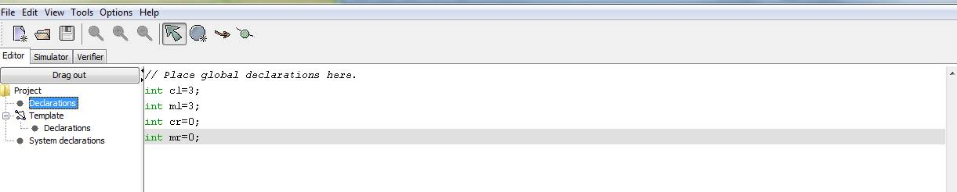

**Figure 2 : Global declaration**

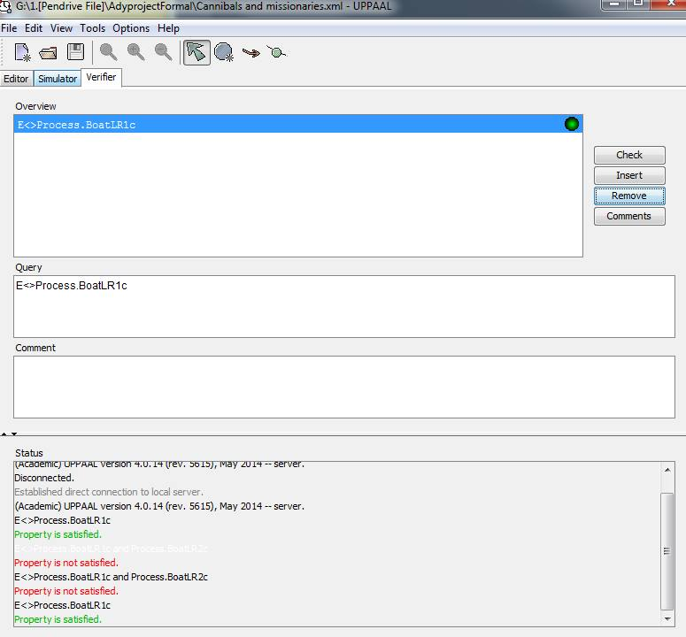

**Figure 3 : Verify**

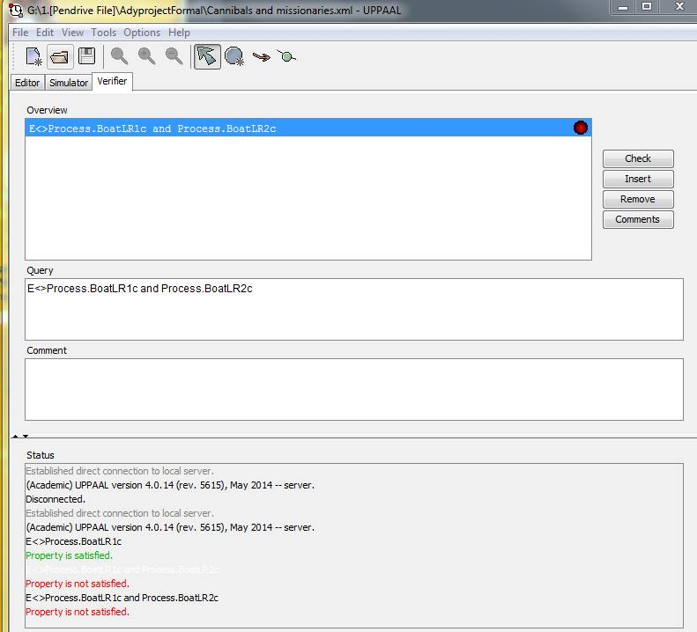

**Figure 4 : Verify**

**CONCLUSION**

The title of this project is “The Cannibals”. This main purpose of this project is discusses about the formal specification of The Cannibals using Temporal Logic Action (TLA) language and design verification of embedded system (UPPAAL). Besides that, The TLA specification language is used to permit the simplest and most direct formalization of correctness proofs of concurrent system while UPPAAL is used to [modeling](http://en.wikipedia.org/wiki/Model_checking), validation and verification of [real-time](http://en.wikipedia.org/wiki/Real-time_computing) systems.

This system is also defined by ten of specifications in TLA which are BoatLR1C,BoatLR2C, BoatLR1M, BoatLR2M ,BoatLR1C1M, BoatRL1C, BoatRL2C, BoatRL1M, BoatRL2M ,BoatRL1C1M. Each specification TLA represented the process of this system. There is also TypeOK that is used to set a constant to each variable and each variable will only hold the value of its constant. The last one is Theorem that is used to show the connectivity between specification and TypeOK is true.

Lastly, what we’ve learned from this project is about team work skills for group projects. To work together successfully, group members trust one another enough to share their own ideas and feelings and also group members demonstrate support for one another as they accomplish their goals. Without team working, we will unable to finish this project on the time. While doing this project, we have facing some problem such as constraints in technical support because of we can’t run UPPAAL tool to implement The Cannibals process, so that we need do in laboratory in FSK25. But we are finally doing our project on time and successfully.

In conclusion, This’ The Cannibals System’ is about nothing has been stated about the properties of boats or even the fact that rowing across the river doesn't change the numbers of missionaries or cannibals or the capacity of the boat. Indeed it hasn't been stated that situations change as a result of action. These facts follow from common sense knowledge, so it make us imagine that common sense knowledge, or at least the relevant part of it, is also expressed in order logic.

**REFERENCE**

|  |  |
| --- | --- |
|  | ["Cannibalism Definition"](http://dictionary.reference.com/browse/cannibalism?r=66). Dictionary.com. |
|  | ["cannibalism (human behaviour)"](http://www.britannica.com/EBchecked/topic/92701/cannibalism). Britannica Online Encyclopedia. Retrieved August 31, 2013. |
|  | Brief history of cannibal controversies; David F. Salisbury, August 15, 2001, Exploration, Vanderbuilt University. |
|  | From primitive to post-colonial in Melanesia and anthropology. Bruce M. Knauft (1999). University of Michigan Press. p. 104. ISBN 0-472-06687-0 |
|  | Peggy Reeves Sanday. "[Divine hunger: cannibalism as a cultural system](http://books.google.com/books?id=SYW6EzB9rYkC&pg=PA151&dq=&hl=en#v=onepage&q=&f=false)". |
|  | Rubinstein, W. D. (2004). [Genocide: a history](http://books.google.com/books?id=nMMAk4VwLLwC&pg=PA17&dq#v=onepage&q=&f=false). Pearson Education. pp. 17–18. [ISBN](http://en.wikipedia.org/wiki/International_Standard_Book_Number) [0-582-50601-8](http://en.wikipedia.org/wiki/Special:BookSources/0-582-50601-8). |
|  | Culotta, E. (October 1, 1999). "Neanderthals Were Cannibals, Bones Show". Science (Sciencemag.org)286 (5437): 18b. doi:10.1126/science.286.5437.18b. Retrieved August 30, 2009. |
|  | Gibbons, A. (August 1, 1997). "Archaeologists Rediscover Cannibals". Science (Sciencemag.org) 277(5326): 635–7. doi:10.1126/science.277.5326.635.PMID 9254427. Retrieved August 30, 2009. |
|  | McKie, Robin (May 17, 2009). ["How Neanderthals met a grisly fate: devoured by humans"](http://www.guardian.co.uk/science/2009/may/17/neanderthals-cannibalism-anthropological-sciences-journal). The Observer(London). Retrieved May 18, 2009. |